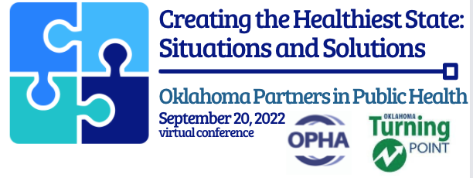

June 2, 2022

Please join us as a sponsor of the 2nd Annual Oklahoma Partners in Public Health conference! We truly appreciate the support of our sponsors in making this conference possible. This year’s conference theme is “Creating the Healthiest State: Situations and Solutions” and we look forward exploring it with you along with our other sponsors, presenters, and attendees.

Our joint educational efforts will view the current health and social landscape of Oklahoma while showcasing the innovative solutions being implemented. We are also excited to announce our keynote address will be from Kaye Bender, PhD, RN, FAAN, President of the American Public Health Association, presenting “Collective Voices for a Better & Stronger Oklahoma.”
Our organizations and conferences have been at the forefront of public health in Oklahoma for a collective 108 years. The Oklahoma Public Health Association (OPHA) assists in protecting and promoting public health, to provide for scientific advancement with the enlightenment of its members through the interchange of information, ideas, and experiences; and to advance the public health program in the State of Oklahoma. Since 1918 OPHA has brought public health professionals together allowing them to network, to share resources and to speak with one voice. OPHA is an affiliated association of the American Public Health Association (APHA).
The Oklahoma Turning Point Council (OTPC) established in 1997 with a vision of creating a healthier future and improving the quality of life for Oklahomans through partnerships. Working across diverse sectors, OTPC provides guidance and support to local health improvement organizations as we work to implement the Oklahoma Health Improvement Plan (OHIP) through the alignment of local and state-level public and community health efforts. In 2021, OTPC enhanced its annual education efforts through joining forces with the Oklahoma Public Health Association to offer this joint educational conference to better meet the needs of Oklahoma’s health care professionals.
The Public Health Institute of Oklahoma (PHIO) is a nonprofit organization which serves as the fiduciary agent for the conference sponsorships. PHIO is the fiscal agent and managing partner of OTPC and is a member of the National Network of Public Health Institutes.

We look forward to having you for another amazing conference! Please complete and email the form to jill@publichealthok.org. Join us and stay tuned for more presenters, topics, breakouts, and sponsors!

Yours in health,
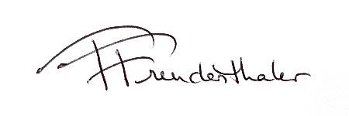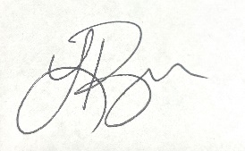
Tracy Freudenthaler, OPHA Laura Ross, OTPC
Conference Planning Co-Chair Conference Planning Co-Chair

